Accel Precalc **Quiz 14: Sum and Difference Formulas** Name ______________________

Unit 7: Trig Identities and Equations **[45 pts]**

* **Formula Sheet Allowed. 4-FUNCTION CALCULATOR ONLY. [REMEMBER: IT WILL BE “NO CALCULATOR OR FORMULA SHEET” IN CALCULUS.]**

1. Simplify each expression as a **trig function of a** **single** **angle**. **DO NOT EVALUATE. [2 pts each]**
2.  ____________________________

2.  ___________________________

3.  ___________________________

1. Find the ***EXACT VALUE*** using a sum or difference formula. ***Show all work in an organized* *manner in the space provided*. *Answer should not contain fractions in the numerator or denominator. All fractions in final answer should be reduced.* [5 pts each]**

* ***For Extra Credit Answer, you can rationalize denominators (if applicable). That means answer contains NO RADICALS in the denominator. You must show all the work required to get the rationalized answer.* [EC = +2 pts]**

***Answers having no supporting arithmetic work will not be scored.***

4.  Answer: ____________________ EC (if applicable) = ____________________

WORK:

5.  Answer: ____________________ EC (if applicable) = ____________________

WORK:

6.  Answer: ____________________ EC (if applicable) = ____________________

WORK:

1. Find the **exact value** using a sum or difference formula. **Show all work in an organized manner. *Fractions should be reduced. Answer should not contain fractions in the numerator or denominator.* [8 pts each]**

**\*\*\* Sketch α and β before you begin each problem. *Answers having no supporting arithmetic work will not be scored.***

7. Given  

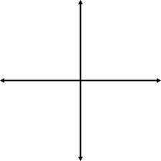

WORK:

Answer: _________________

8. Given 

WORK:

Answer: _________________

9. Given 

WORK:

Answer: _____________________