**My signature on this assessment confirms I have used no outside resources and adhered to all assessment protocols assigned to this daily grade/quiz/test/exam.**

Accel Precalc Quiz #11 Name ___________________________

Unit 6: Graphs and Inverses of Trig Functions

Lessons 5, 6: Graphing Secant, Cosecant, Tangent, and Cotangent

**NO UNIT CIRCLE. 4-FUNCTION CALCULATOR ONLY.**

* **#1 – 8. Complete the following table.[16 total points]**

|  |  |  |  |  |
| --- | --- | --- | --- | --- |
| **Function** | **Amplitude** | **New Period** | **Phase Shift with Direction** | **Vertical Shift with Direction** |
| y = -6cot(2x - ) + 4 | 1. | 2. | 3. | 4. |
| y = 3sec(x + 3π) - 2 | 5. | 6. | 7. | 8. |

* **Choose the letter of the correct graph for the given equation. There is only *one* correct answer. Follow scale given on each graph. [4 pts each]**



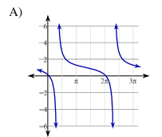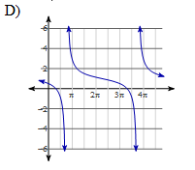______9.

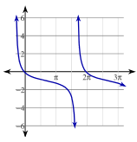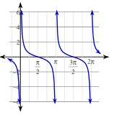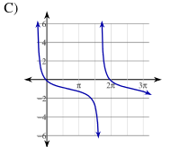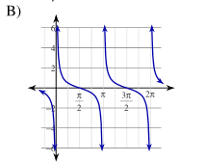



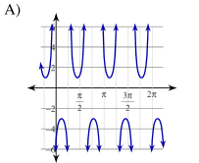______ 10.

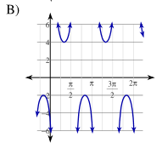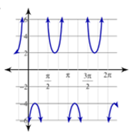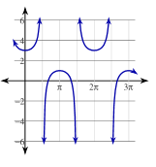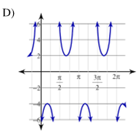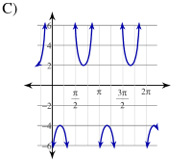

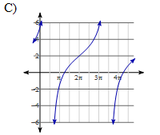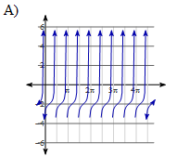______11.

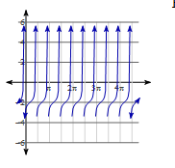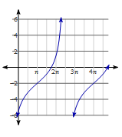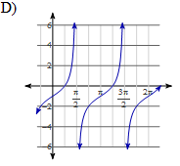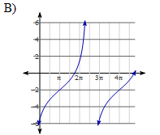



______12.

