**My signature on this assessment confirms I have used no outside resources and adhered to all assessment protocols assigned to this daily grade/quiz/test/exam.**

Accel Precalc **Quiz #10**  Name ________________________

Unit 6: Graphs and Inverses of Trig Functions

Lessons 1 – 4; Evaluate Trig Functions, Graphing Sine and Cosine; Amplitude, Period, Phase Shift, Vertical Displacement **[45 total pts]**

**Four-Function Calculator Only**

* Choose the letter for the correct equation for the given graph. There is only ***one*** correct answer.[4 pts each]

**Use these interval for ALL graphs: Intervals on x-axis:**   **Intervals on y-axis:** 1

1. A. y = -cos(x + ) ________ 2. A. y = sin x + 1 ________

B. y = sin (x) – 2 B. y = cos (x - ) +1

C. y = sin (x – ) C. y = -2sin x + 1

D. y = -2 cos (x) D. y = -2cos x + 1

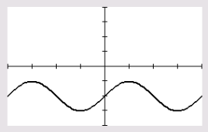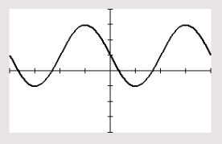

3. A. y = sin (x – π) __________ 4. A. y = sin ( ½ x ) + 1 _________

B. y = cos (x + π) B. y = cos (2x) + 1

C. y = sin (x –) C. y = cos ( ½ x ) + 1

D. y = cos (x – π) D. y = sin (2x) + 1

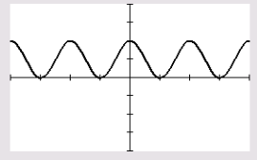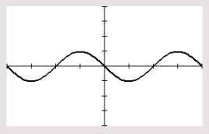

* 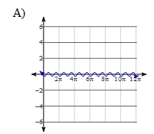Choose letter for the correct graph for the equation. There is only ***one*** correct answer. Follow scale given on each graph .[4 pts each]

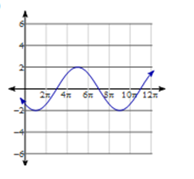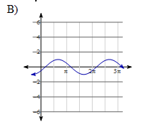

5. _________

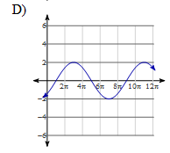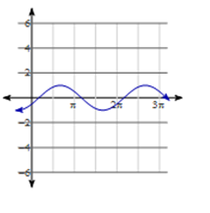

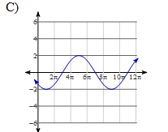

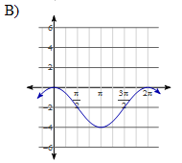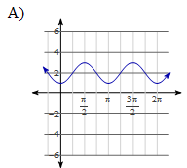



6. ___________

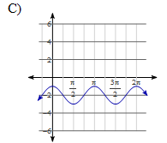

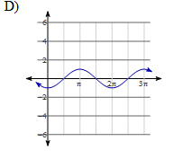

7. Write the equation of a **sine function** given the following information.[4 pts]

amplitude = 3 new period = π phase shift = π/4 left vertical shift = 1 up reflect across x-axis

y = _______________________________________

8. Write the equation of a **cosine function** given the following information.[4 pts]

amplitude = 5 new period = 4π phase shift = π/2 right vertical shift = 3 down no reflection

y = ______________________________________

* Give the **exact value** for each of the following. **Reduce all fractions**.[3 pts each]

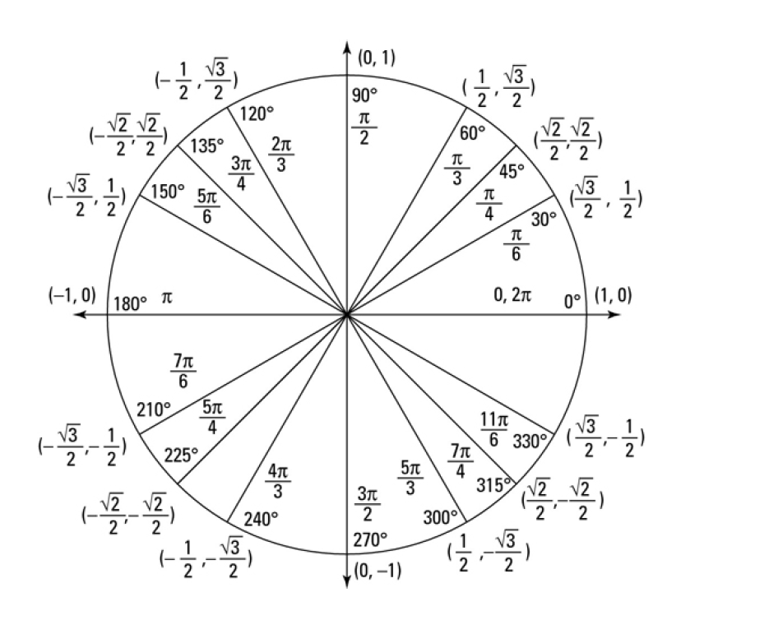

9. cos  ____________

10. tan  _____________

11. csc _____________

12. Given the point that corresponds to the angle θ in the coordinate plane, find the

**exact value** of tan θ. [3 pts] _____________

13. State the quadrant in which θ lies given cot θ < 0 and sec θ > 0.[1 pt] ______